Working from the full uploaded PDF (no retrieval needed). Using the v3.10 framework in the project — the triggers you pasted reference v3.9, which v3.10 supersedes, so I'm going with the current file.

1 — Handedness in the Debris
Twisting light into a corkscrew, on top of spinning it, quadruples the chiral signal you can read straight off a camphor mass spectrum — no chromatography, no derivatization, no electron detection.

2 — Big-Picture Context
Telling enantiomers apart — mirror-image molecules that can behave completely differently in a body — is a workhorse problem in pharma and diagnostics, and the existing toolkit is either invasive or faint. Chiral HPLC works but needs chemical separation or tagging. The optical methods (circular dichroism, vibrational CD, Raman optical activity) measure genuine handedness but ride on a weak effect and typically want high concentrations and fussy optics. Photoelectron CD (PECD) does better (~10% contrast) but pays for it with angle-resolved electron detection and coincidence measurements. The open lane: something simple, gas-phase, derivatization-free, and high-contrast.
The reason standard chiroptical signals are small is mechanistic, and it's worth stating up front because the whole paper turns on it. Ordinary CD gets its handedness sensitivity from the interference between a molecule's electric-dipole (E1) response and its much weaker magnetic-dipole (M1) response. M1 is intrinsically tiny (roughly the fine-structure constant, ~1/137, down on E1), so the asymmetry is a whisper.
This paper finds a louder channel. It irradiates camphor vapor with intense femtosecond pulses that carry two independent kinds of twist — the familiar spin of circular polarization (SAM) and the less-familiar orbital angular momentum (OAM), where the whole wavefront is wound into a helix. It reads the result directly off fragment-ion yields in a time-of-flight mass spectrometer, and gets a contrast up to G ≈ 0.4 — about fourfold over either twist alone.
Paper Type & Stakes: this is a primarily experimental paper with a supporting symmetry-based theory, demonstrating a new detection modality — chirality read off strong-field mass spectra using structured light. If it's robust and general, it's a simpler, scalable chiral sensor; if the effect is partly molecule-specific or partly artifact, it's a narrower (still interesting) proof-of-concept.
Prior Belief Check. The general idea that OAM can couple to molecular chirality is not new to experts — "helical dichroism" has been reported in nanostructures, disordered media, and free molecules (the Forbes–Andrews theory papers, and the Bégin/Bhardwaj experiments, are cited). What would raise expert eyebrows: (a) the size — G ≈ 0.4 is large for this class; (b) the specific claim that SAM and OAM act cooperatively, neither sufficient alone, with a clean parity-of-ℓ signature; and (c) doing it in a mass spectrometer with fragment-resolved contrast. Crucially, this sits in a genuinely contested corner: prior free-molecule OAM contrasts appeared mainly with misaligned beams, and the field has openly debated whether such effects are real or alignment artifacts. So this is neither confirmatory nor a settled overturning — it's a strong new data point in an unsettled subfield, staking out a specific, checkable mechanistic position.
Replication & Convergence Note. Single group, single apparatus, single molecule (IIT Hyderabad and collaborators). The broad phenomenon has independent antecedents elsewhere, but this approach — the fourfold synergy and the parity evidence — has no independent replication yet. Convincing confirmation would be a different lab, different apparatus, ideally a different chiral molecule, reproducing (i) the fourfold SAM+OAM enhancement, (ii) the (−1)^|ℓ| parity flip, and (iii) the enantiomer sign reversal. This matters more than usual here because the two enantiomers give signals that flip sign but don't match in magnitude (0.4 vs −0.14) — exactly the shape a hidden systematic can take.

3 — Necessary Background Crash-Course
Concept 1 — Two independent twists of light (SAM vs OAM). Circularly polarized light carries spin angular momentum, ±ℏ per photon: the electric-field vector rotates as the wave goes by. OAM is separate — the phase front itself is a corkscrew, labeled by an integer topological charge ℓ, carrying ℓℏ per photon, and it has nothing to do with polarization.
Analogy: SAM and OAM are two orthogonal fields in the photon's record — like two independent columns in a struct you can set separately. Spin-up light can be spatially untwisted; spatially-twisted light can be linearly polarized; or you can set both.
Breaks when: you treat them as independent everywhere. Under tight focusing (high numerical aperture), spin and orbital parts couple (light's own spin-orbit coupling). Here the beam is weakly focused (NA = 0.04), so the "independent columns" picture holds — but that's a property of this setup, not of light in general.
Here's what the helical (ℓ = +1 vs ℓ = −1) phase front actually looks like, since it's the least intuitive of the two twists:
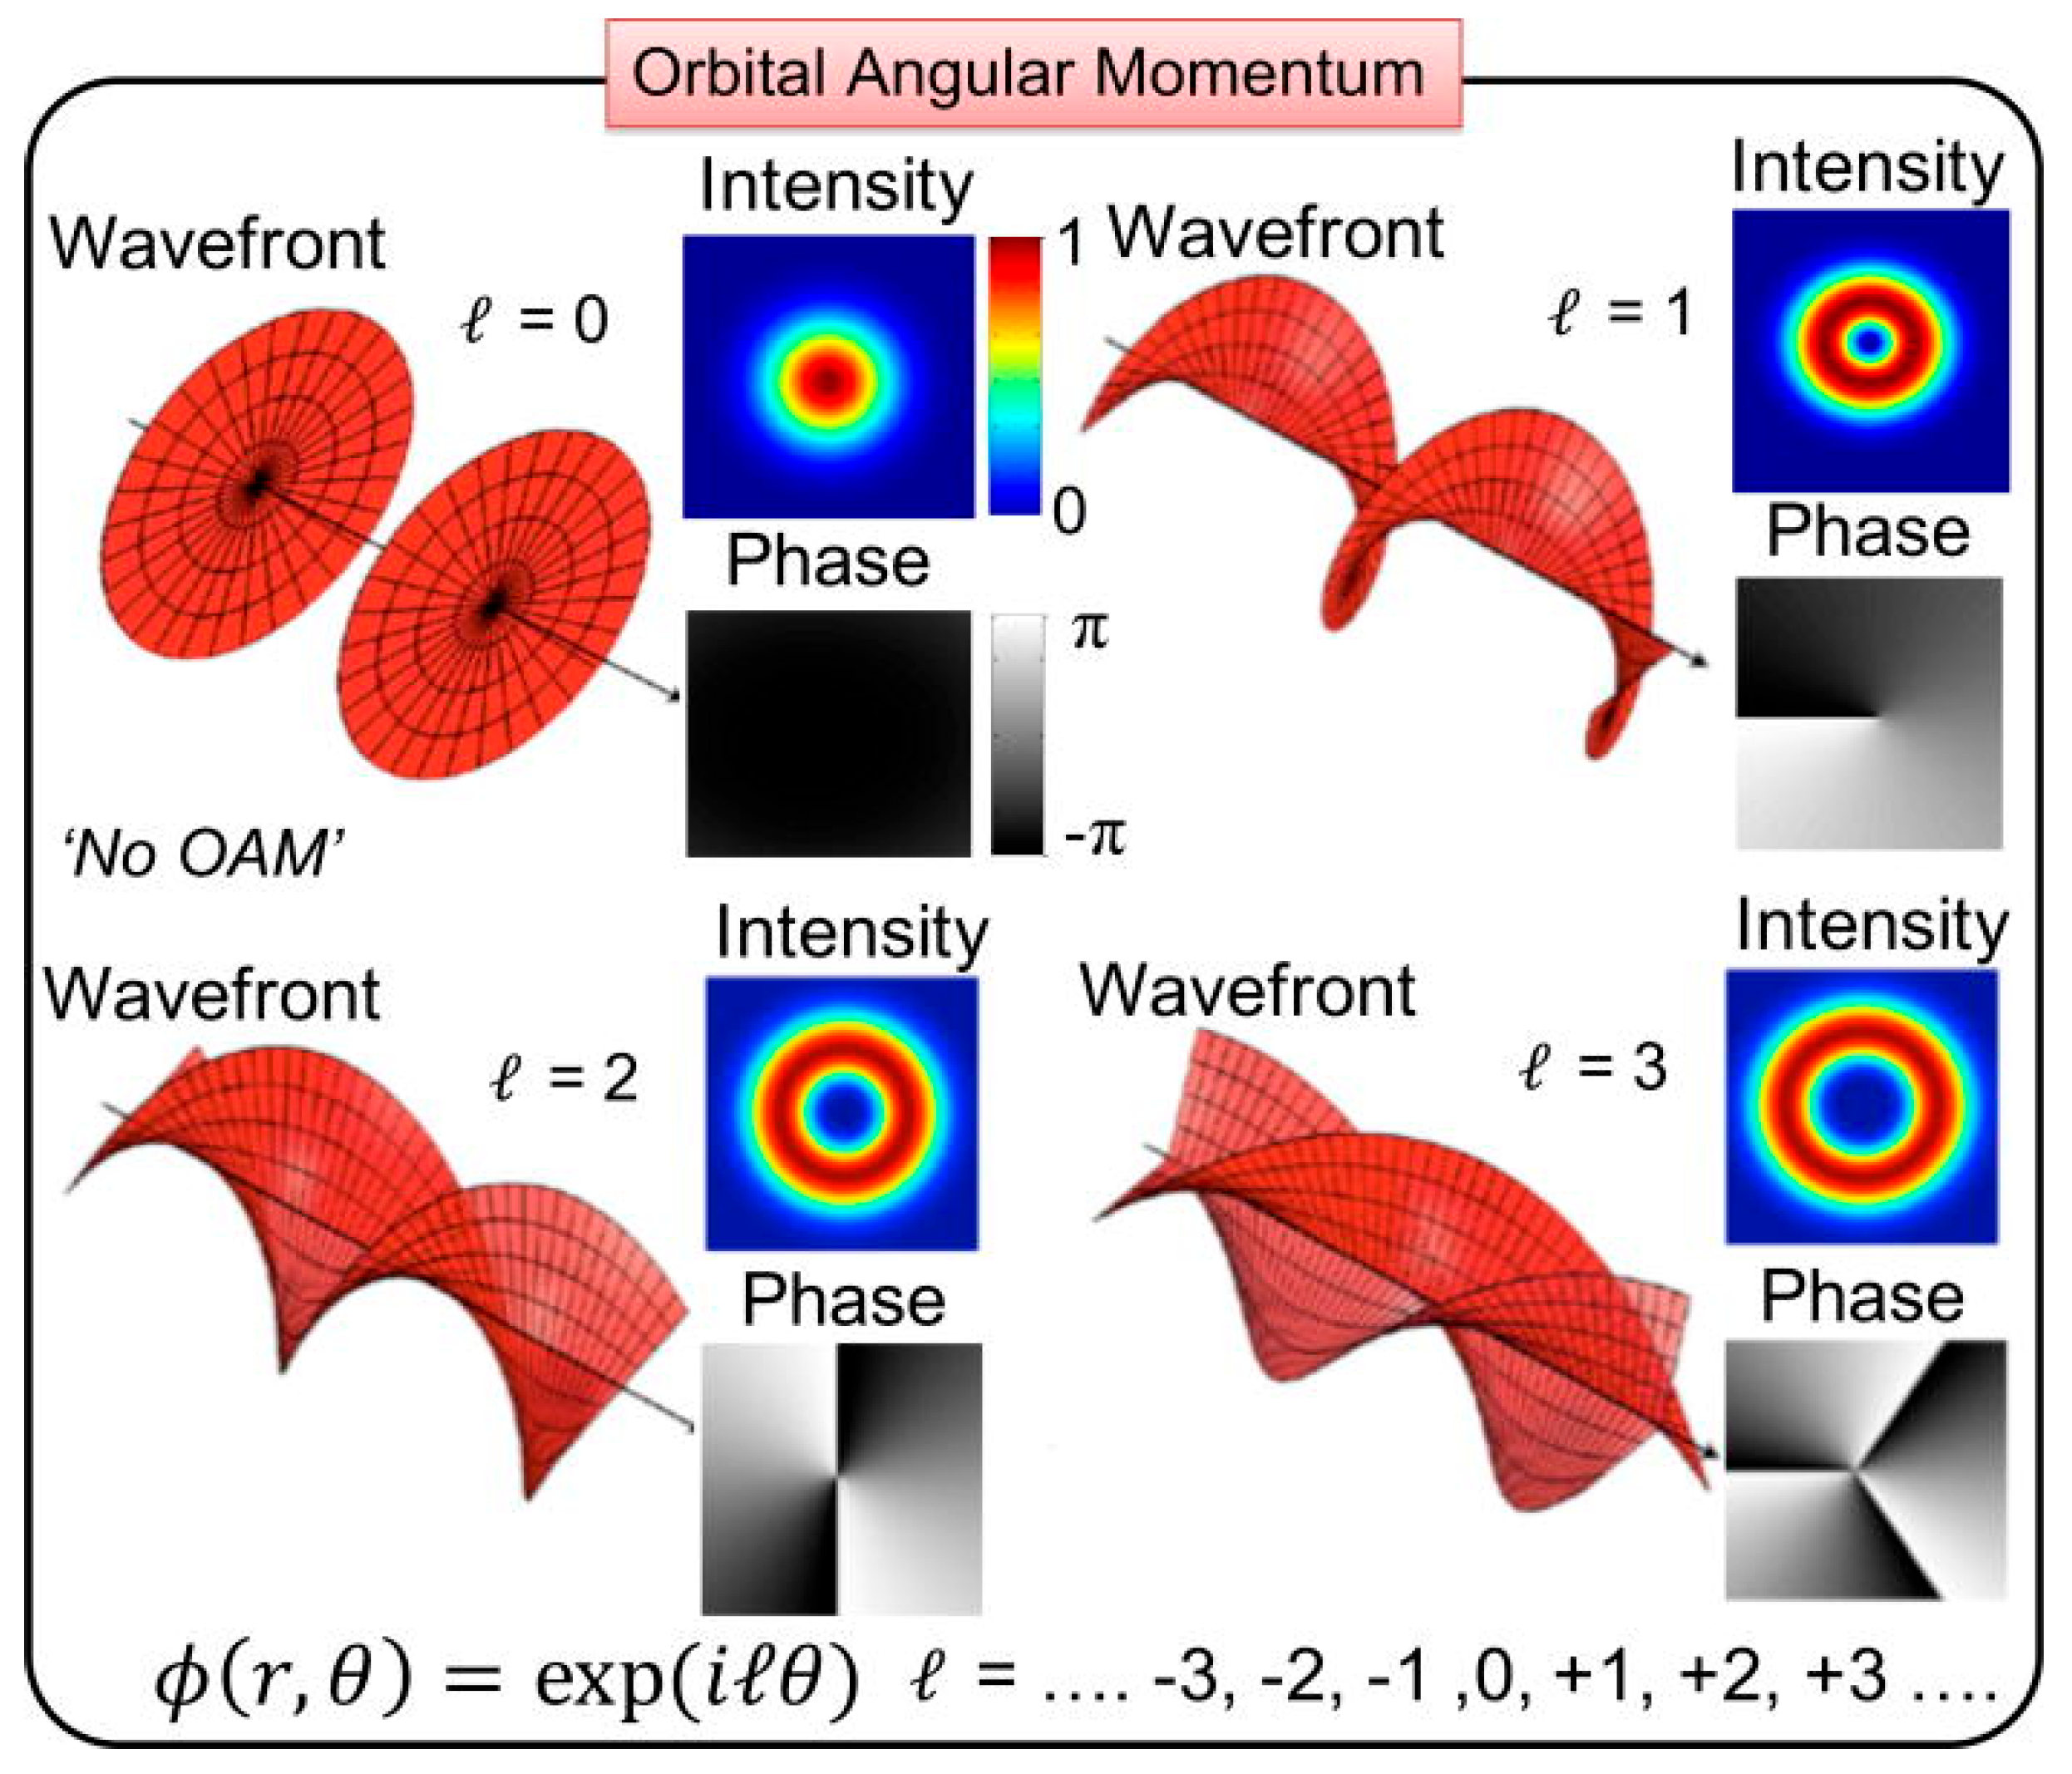
mdpi
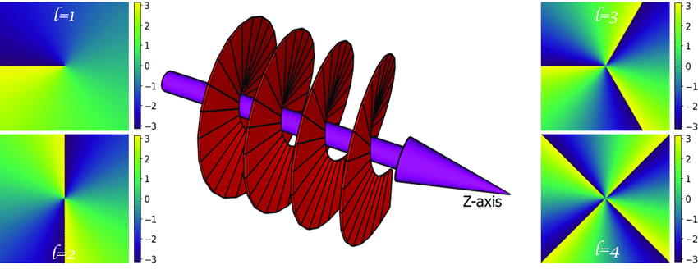
researchgate
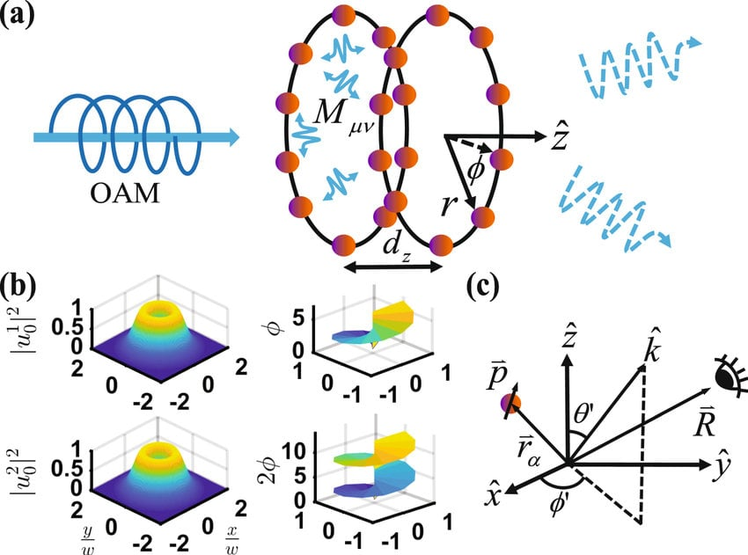
researchgate
Results from the web
The two mirror-image wavefronts (ℓ = +1 and ℓ = −1) wind in opposite senses — that opposite winding is the "handedness of the light" that couples to the molecule's handedness.
Concept 2 — Chiral contrast as a differential measurement. A chiral molecule ionizes very slightly differently under one light configuration versus its mirror; the fractional difference is the contrast. Standard values are small (fractions of a percent to a few percent).
Analogy: it's a diff. You're not measuring an absolute yield — you're diffing two nearly-identical runs and normalizing to the total, so common-mode gain drift cancels, exactly like caring only about the handful of bytes that differ between two large files. G = 0 means the two configs are indistinguishable.
Breaks when: you assume big contrast = "better molecule." Contrast here is a property of the light–molecule–intensity combination, not an intrinsic molecular constant — turn the intensity up and it shrinks (saturation, §4).
Concept 3 — The multipole ladder and parity (the load-bearing idea). Light–matter coupling expands into terms: electric dipole (E1) is leading; magnetic dipole (M1) and electric quadrupole (E2) are the next, smaller terms. The fact that matters: E1 is parity-odd; M1 and E2 are parity-even. Chiral sensitivity requires interfering a parity-odd term with a parity-even one. Standard CD uses E1×M1. This paper uses E1×E2.
Analogy: think of it as a parity check / checksum that only flags handedness when you combine a parity-odd channel with a parity-even one. E1 alone or E2 alone gives a magnitude but no handedness bit; the chiral bit lives entirely in the cross-term — the product.
Breaks when: you file E2 as "just another weak correction like M1." The trick is that OAM light has a strong transverse phase gradient, and E2 couples to field gradients — so twisting the light pumps up the normally-negligible E2 channel until E1×E2 rivals or beats E1×M1. OAM is what makes this route competitive.
Concept 4 — Strong-field ionization + laser alignment. At 10¹²–10¹³ W/cm², an 800 nm photon (1.55 eV) can't singly ionize camphor (ionization energy ~8.7 eV) — it takes ~6+ photons (multiphoton/strong-field), and the molecule then fragments. Second, less obvious point: at these intensities the field grabs camphor's anisotropic polarizability and partially aligns the randomly-oriented molecules during the pulse.
Analogy: the alignment is a sort step before the scan. For a fully shuffled (isotropic) ensemble, the E1–E2 signal averages to zero over all orientations; the laser-induced alignment breaks isotropy — it sorts the data enough that a net E1–E2 signal survives the average.
Breaks when: you read "multiphoton" as just a high threshold. The broad bandwidth of ultrashort pulses opens many competing excited-state pathways, and those pathways — not the threshold — govern how much chiral contrast survives. That's why pulse duration is a knob (short pulse → more pathways → washed-out contrast).
Central analogy for this paper: the cross-term — OAM amplifies, SAM gates.
Lock that in: the handedness signal lives in an E1–E2 interference cross-term; orbital twist sets its size, spin decides whether it's switched on at all. Everything below hangs on it.

4 — Core Technical Explanation
The apparatus. An 800 nm, 1 kHz, ~5 mJ system delivering 25 fs–850 fs pulses. A spiral phase plate imprints the OAM (ℓ = ±1, ±2); a quarter-wave plate sets the circular polarization (SAM, s = ±1). Weak focusing (f = 30 cm, ~75 µm spot, NA 0.04) keeps things paraxial so SAM and OAM stay independent. Camphor comes in as an effusive jet; ions are read by a TOF mass spectrometer. Two nice controls: opposite OAM sign is made by rotating the same phase plate 180° (same optic, so systematics largely cancel), and handedness is switched every 300 s within a single run so long-term drift cancels. Achiral O₂ sets the noise floor.
The chemistry is the part you already know cold — camphor (C₁₀H₁₆O, parent at m/q = 152) shatters by standard routes: CO loss, ketene + methyl loss, ring cleavages giving the C₄H₇⁺/C₃H₅⁺/C₄H₅O⁺ series at m/q 55, 41, 69, and the linear fragments at 81/83. Nothing exotic in the fragmentation; the physics is all in which handedness of light favors which fragment.
The one metric that matters — the contrast G:
G=Nℓ,s−Nℓ′,s′Nℓ,s+Nℓ′,s′G = \frac{N_{\ell,s} - N_{\ell',s'}}{N_{\ell,s} + N_{\ell',s'}}G=Nℓ,s​+Nℓ′,s′​Nℓ,s​−Nℓ′,s′​​
Symbol definitions:
- Nℓ,sN_{\ell,s} Nℓ,s​ : normalized ion yield (counts under an m/qm/q m/q peak, divided by total ion counts) for light with twist ℓ\ell ℓ and spin ss s
- Nℓ′,s′N_{\ell',s'} Nℓ′,s′​ : the same, for the mirror light configuration (flipped ℓ\ell ℓ and/or ss s)
- GG G : the normalized difference (dimensionless, from −1 to +1)
What this actually means: G is a relative-difference metric immune to overall gain — numerator = "how different are the two runs," denominator cancels the common scale. G = 0 → the two handedness configs are indistinguishable; |G| = 1 → one config makes the ion, the mirror makes none.
Worked micro-example (representative counts consistent with the reported G): for the flagship pair (ℓ=+1, s=+1) vs (ℓ=−1, s=+1), if the m/q = 41 peak collects 140 normalized counts one way and 60 the mirror way, then G = (140 − 60)/(140 + 60) = 80/200 = 0.4. That single number is the headline. The O₂ floor is ~0.05, so 0.4 is ~8× the noise floor — while SAM-alone and OAM-alone sit at 0.07–0.10, barely above it.
The results, in the order that builds the argument:
- SAM alone (ℓ=0, flip spin): G ≈ 0.07 — barely above the 0.05 O₂ floor.
- OAM alone (linear polarization, s=0, flip twist): G ≈ 0.10 ± 0.07 — essentially floor. Twist alone doesn't do it.
- Same twist, opposite spin (ℓ=+1, s=±1): G ≈ 0.03 — nothing.
- SAM + OAM (ℓ=+1,s=+1 vs ℓ=−1,s=+1): G ≈ 0.4. The jump.
This is an interaction effect, not a sum of main effects — like a cache that only pays off when you have both temporal and spatial locality; either alone is marginal, together they compound. An AND-gate: both inputs must be high.
- Fragment-resolved sign structure: ions with m/q ≤ 81 have G ≥ 0; heavier (parent-ward) fragments have G ≤ 0, with an inflection at m/q = 81/83 — echoing known mass-dependent sign reversal in CD.
- Enantiomer test: (1S) → G = +0.4; (1R) → G = −0.14. Sign flips (as a real chirality probe must); magnitudes don't match (held for §6).
- Parity of ℓ: for ℓ = ±1 the ℓ = −1 state gives higher yield; for ℓ = ±2 it reverses to ℓ = +2. This (−1)^|ℓ| flip is the strongest evidence the twist itself is driving things — a mundane alignment artifact has no way to know the parity of the phase winding. G(|ℓ|=2) = 0.31.
- Pulse duration: 25 fs → G ≈ −0.08 (floor); rises to a max near ~450 fs; saturates by 850 fs. Short pulse = broad bandwidth = many excited-state pathways = washed-out contrast; longer pulse = more selective excitation + more alignment.
- Intensity: higher intensity → lower contrast — ground-state depletion, and the peak field's overall ionization rate swamping the gradient-driven (helicity-dependent) part.
The mechanism, kept light. In the Power–Zienau–Woolley multipole Hamiltonian, the interaction splits into an E1 (dipole) term and an E2 (quadrupole) term. For a Laguerre–Gaussian (twisted) beam, OAM enters through the transverse azimuthal phase gradient ∂/∂φ, which shows up only in the field-gradient (quadrupole) piece — the pure dipole term is OAM-blind. The observable is the interference of the two. Rather than reproduce their heavy Eqs. 5–7, the essential structure is:
Signal ∝ ∣D+Q∣2 = ∣D∣2+∣Q∣2+2 Re(D∗Q)\text{Signal} \;\propto\; |D + Q|^2 \;=\; |D|^2 + |Q|^2 + 2\,\mathrm{Re}(D^{*}Q)Signal∝∣D+Q∣2=∣D∣2+∣Q∣2+2Re(D∗Q)
Symbol definitions:
- DD D : electric-dipole (E1) transition amplitude — OAM-independent
- QQ Q : electric-quadrupole (E2) amplitude — carries the OAM phase-gradient dependence
- 2 Re(D∗Q)2\,\mathrm{Re}(D^{*}Q) 2Re(D∗Q) : the interference cross-term — the chiral-sensitive part
What this actually means: ∣D∣2|D|^2 ∣D∣2 and ∣Q∣2|Q|^2 ∣Q∣2 are "self" terms, blind to relative handedness; the handedness bit lives entirely in the cross-term. And the paper's fuller algebra pins down when that cross-term survives: it comes out proportional to (ε^∗×ε^)(\hat{\varepsilon}^{*}\times\hat{\varepsilon}) (ε^∗×ε^), the polarization vector crossed with its own conjugate — which is zero for linear polarization and nonzero only for circular. So the math itself says: no spin → no signal, regardless of twist. OAM sets the size of QQ Q; SAM decides whether the cross-term is switched on. (The central analogy, restated by the equations.)
Assumption Audit
Watch: Reader likely assumes the theory (Eqs. 2–7) predicts the ion yields they measure. The paper actually derives a photoelectron current-density asymmetry — an angle-resolved electron observable — then argues by analogy that the same E1–E2 interference governs the fragment-ion contrast. The link from computed electron-current asymmetry to measured ion yield is qualitative, not a first-principles calculation of G.
Watch: Reader likely assumes "OAM is chiral, so OAM alone should discriminate." The paper actually shows OAM alone (linear polarization) sits at floor — by their own symmetry argument the ±ℓ differential-absorption signal vanishes for linear polarization. Twist is necessary but not sufficient; spin unlocks it.
Watch: Reader likely assumes the intense field is just the ionization tool. The paper actually leans on it to align the molecules — for a strictly isotropic, weak-field ensemble the orientationally-averaged E1–E2 term vanishes, so the field-induced alignment (breaking isotropy) is what lets the mechanism be nonzero at all. The same intensity that ionizes is what makes the effect exist.
Three genuine, non-obvious items — no manufactured fourth.

5 — What's Genuinely New or Clever
Trick 1 (the conceptual core): recognizing that OAM's transverse phase gradient pumps the normally-negligible E2 channel, opening an E1–E2 interference route to chiral contrast as an alternative to standard CD's weak E1–M1 route — and that SAM gates it. The reframing "twist amplifies, spin switches on" is the real contribution. The OAM–chirality coupling was theorized earlier (Forbes & Andrews); new to the field here is the strong-field mass-spec realization, the cooperativity, and the parity evidence.
Trick 2 (the detection): reading handedness straight off fragment-ion yields in a TOF mass spec — no angle-resolved electron detection, no coincidence, no derivatization — with fragment-resolved contrast (different m/q, different sign) as a free extra fingerprint.
New to reader vs. field: the coupling theory is recent-ish to the field (~2018–2023); the mass-spec realization and the cooperativity/parity evidence are the genuinely new-to-field pieces.
Predictive Content Check (the §5→§6 hinge)
- Falsifiable handle (always): the paper predicts, it doesn't merely relabel. Sharp, checkable claims: (i) linearly-polarized OAM must give zero chiral contrast (the cross-term ∝ ε*×ε = 0) — tested, and consistent with zero given the beam is only ~92% linearly polarized; (ii) the parity prediction — contrast sign flips as (−1)^|ℓ|, so going to |ℓ| = 3 should flip the sign back to the |ℓ| = 1 pattern, a clean, not-yet-done test; (iii) a scaling: theoretical contrast ∝ ℓ, partly offset by an |ℓ|/r falloff (since r_max ∝ √|ℓ|). Stated plainly, though: the sign structure is predicted and partly confirmed, but the magnitudes (0.4; the enantiomer asymmetry) are described, not predicted — the theory doesn't compute them. So: predicts signs, relabels magnitudes.
- Formalism load (conditional — firing here because the paper leans hard on the Theory section and there's a real question whether all of it works): partially load-bearing. The (ε*×ε) gate is doing genuine work — a real, testable prediction (linear → null, circular → max, monotonic in ellipticity) that the experiment checks. The linear-in-ℓ dependence is real too. But the full photoelectron current-density apparatus is heavier than the qualitative claims it actually supports, and it computes an electron-angular observable while the experiment measures ion yields — so much of the detailed cross-product machinery never directly touches the reported numbers. Net: the symmetry skeleton (E1/E2 parity, the ε*×ε gate, linear-in-ℓ) is load-bearing; the detailed current-density derivation is largely decorative with respect to what's measured. Not fatal — but this is exactly the tail case the conditional test exists to name.

6 — Limitations & Open Questions
Enantiomer magnitudes aren't equal-and-opposite (0.4 vs −0.14). The sign flips, but the ~3× magnitude gap is unexplained beyond "nonlinear, many parameters." (B) Contested — reasonable people differ on whether this is an expected feature of a nonlinear, alignment-dependent process or a fingerprint of an uncontrolled systematic. (paper, Discussion)
The theory computes an electron-current asymmetry, not the measured ion-yield contrast. The mechanistic story is a symmetry-level rationalization of G, not a predictor of it. (A) Consensus — the paper itself frames the theory as "qualitative insight." (paper, Theory/Discussion)
One molecule, one apparatus, one group. Generality across chiral species is untested. (A) Consensus — standard for a first demonstration. (analyst inference / broader literature)
Free-molecule OAM chiral effects sit in a contested area (genuine vs. artifact). Prior contrasts appeared mainly with misaligned beams, and the community has debated their reality. This paper's controls are strong (parity flip, enantiomer sign flip, O₂ floor, in-run handedness switching, verified centered singularity) — but strong single-group controls ≠ settled. (B) Contested — the genuineness argument is convincing, not conclusive. (broader literature + paper)
The linear-polarization "null" is 0.10, not 0 — attributed to ~92% polarization purity. Plausible, but it means the cleanest test of SAM-gating isn't a clean null; some claimed gating could be muddied by imperfect optics, or could hint at a small OAM-only effect the symmetry argument misses. (B) Contested — could be exactly the impurity, could be something the model omits. (paper, Discussion / analyst inference)
The intensity-dependence mechanism (gradient-driven vs. peak-field-driven ionization) is asserted, with "extensive numerical simulations will confirm." Currently a plausible narrative awaiting the promised simulation. (C) Speculative — my read that this story is not yet quantitatively backed. (analyst inference)
12–24 month follow-ups: the |ℓ| = 3 parity test; other chiral molecules; the promised simulations linking field gradients to ion yields; a first-principles calculation of G (not just the electron-current asymmetry); and independent replication.

7 — Detailed Summary & Explanation
The problem is old and practical: distinguish left- from right-handed molecules, cheaply and sensitively, in the gas phase. Standard optical handedness measurements are faint because they rely on the interference between a molecule's electric-dipole response and its much weaker magnetic-dipole response, and they usually demand concentrated samples or elaborate detection. This paper opens a different channel. The authors hit camphor vapor with intense ultrashort laser pulses and read handedness directly from the mass spectrum — the pattern of charged fragments — quantified by a single number, the contrast, which is just the normalized difference in fragment yield between one light configuration and its mirror.
The move that makes it work is giving the light two independent kinds of twist at once: the spin of circular polarization, and orbital angular momentum, where the entire wavefront is wound into a helix labeled by an integer "topological charge." On their own, each twist barely separates camphor's two mirror forms (contrast near the achiral noise floor). Combined, the contrast jumps roughly fourfold, to about 0.4. The physical picture: the handedness information lives in an interference between the molecule's dipole response and its quadrupole response; the orbital twist — through the sideways gradient of its helical phase — amplifies the quadrupole part, and the spin is what allows the interfering term to survive at all. Their own algebra makes the spin requirement sharp: the surviving handedness term is proportional to a quantity that is exactly zero for linear polarization and nonzero only for circular. Twist sets the size; spin sets the on/off switch.
Several independent checks argue the effect is real. Swapping camphor for its mirror image flips the sign of the contrast, as any true handedness probe must. More tellingly, changing the amount of orbital twist from one turn to two flips the asymmetry according to whether the winding number is odd or even — a parity fingerprint that ordinary beam misalignment could not fake. The achiral reference gas gives essentially nothing, pinning the floor. Pulse duration and intensity behave as tunable knobs: very short pulses wash the contrast out (their broad bandwidth opens too many competing excitation pathways), a few hundred femtoseconds is the sweet spot, and higher intensity reduces contrast through saturation.
On the framing: I've centered everything on "a chiral cross-term, twist-amplified and spin-gated" because that single idea explains the fourfold synergy, the linear-polarization null, and the SAM requirement in one stroke — and it's the paper's own mechanism stripped to essentials. I foregrounded the parity flip as the strongest evidence and the enantiomer magnitude mismatch as the main caution, because those are the two things that most determine whether a skeptical reader believes it. I did not materially restructure the framework's sections; the only change worth noting is that I moved the enantiomer-magnitude point out of the Assumption Audit and into the limitations, where it lives more naturally.
Where I'm least confident in this analysis: the internal algebra of the Theory section (Eqs. 5–7). I've translated its structure faithfully — the E1–E2 cross-term, the ε*×ε spin gate, the linear-in-ℓ dependence — but I have not independently re-derived their steps (and the equation transcription in the source is partly garbled), and the physical bridge from their photoelectron-current-density derivation to the measured ion yields is exactly where my plain-language version is thinnest and where I may be leaning on the generic "interference cross-term" template more than tracking their specific math.

8 — Three Crystallized Takeaways
- Ordinary chiral spectroscopy reads handedness off a whisper — the weak interplay between a molecule's electric-dipole and magnetic-dipole response. This paper finds a louder channel: twist the light into a corkscrew and you pump up its electric-quadrupole response instead, and the interference of that with the dipole carries handedness — up to a fourfold stronger signal.
- Neither ingredient works alone. Twist without spin gives almost nothing; spin without twist gives almost nothing; only twist AND circular polarization together produce the big contrast — a genuine cooperative (AND-gate) effect, not a sum of two weak ones. And flipping the molecule's handedness flips the signal's sign, as a real chirality probe must.
- The smoking gun that it's really the twist doing the work: change the twist from one full turn to two, and the asymmetry flips sign, following the odd/even parity of the winding number — something a mundane alignment artifact could never know about. And it all comes straight off fragment peaks in a mass spectrometer: no chromatography, no chemical tagging, no electron detection.

9 — Shorter Summary
Telling left- from right-handed molecules apart matters enormously in drug design and diagnostics, but the standard optical methods lean on a faint effect and usually need concentrated samples, chemical tagging, or elaborate detection. This paper demonstrates a sharper, simpler route: the authors fire ultrashort laser pulses at camphor vapor and read handedness directly off the mass spectrum — the pattern of charged fragments the molecules shatter into.
Their key move is to give the light two independent kinds of twist at once. One is the familiar spin of circularly polarized light; the other, less familiar, is orbital angular momentum — the entire wavefront wound into a corkscrew. On their own, each twist barely distinguishes camphor's two mirror-image forms. Combined, they quadruple the contrast, producing a clear, reliable signal. This cooperation is the heart of the result: the handedness information lives in an interference between two parts of the molecule's response to light, the orbital twist amplifies that interference, and the spin is what switches it on at all — neither ingredient works without the other.
Several checks argue the effect is genuine rather than an artifact. Swapping camphor for its mirror image flips the sign of the signal, as a true handedness probe must. More tellingly, changing the orbital twist from one turn to two flips the asymmetry according to whether the winding number is odd or even — a fingerprint ordinary misalignment errors could not mimic. An achiral reference gas produces essentially no signal, pinning the noise floor.
The honest limitations: the two mirror-image molecules give signals that flip sign but do not match in size, which the authors acknowledge and pin on the messy, highly nonlinear physics involved. The supporting theory explains the signs and the spin requirement but does not calculate the actual numbers, and the whole demonstration rests on one molecule in one laboratory. Independent replication and a fuller theory would turn a striking proof-of-concept into an established technique.
More details on concept 3
Thought for 3m
Explaining
Concept 3 packed a lot into a few lines. Here's the full build — it's the most elegant part of the whole paper, and it rests on symmetry logic you can check by hand.

Why there's a "ladder" at all
A molecule isn't a point — it has finite size, and the light's field varies across it. Write the field the molecule sees as a Taylor expansion in (molecular size ÷ wavelength) and you get a series of correction terms, each smaller than the last by roughly the expansion parameter kaka ka, where k=2π/λk = 2\pi/\lambda k=2π/λ is the wavenumber and aa a is the molecule's size.
Worked number: k=2π/800 nm≈0.0079 nm−1k = 2\pi / 800\text{ nm} \approx 0.0079\ \text{nm}^{-1} k=2π/800 nm≈0.0079 nm−1, and camphor is roughly a≈0.5a \approx 0.5 a≈0.5 nm across, so
ka≈0.0079×0.5≈0.004.ka \approx 0.0079 \times 0.5 \approx 0.004.ka≈0.0079×0.5≈0.004.
That single number is why the corrections are normally negligible. The electric dipole (E1) term couples to the field itself; the next rung down — electric quadrupole (E2) — is suppressed by ∼ka∼0.004\sim ka \sim 0.004 ∼ka∼0.004, and the interference term that carries chirality (which goes as E1×E2, so ∼2×E2/E1\sim 2\times E2/E1 ∼2×E2/E1) lands around 1%. That's exactly the scale of ordinary chiral contrast. It's a Taylor series with a small parameter, and you're living off the second-order term.
The magnetic dipole (M1) term is suppressed by a different small number — roughly the fine-structure constant, α≈1/137≈0.0073\alpha \approx 1/137 \approx 0.0073 α≈1/137≈0.0073 — because magnetic coupling to atomic electrons is a v/cv/c v/c effect. So M1 and E2 are both $\sim$1% corrections, but for unrelated physical reasons: M1 is a relativistic/velocity smallness, E2 is a finite-size smallness. This distinction is the whole game — because OAM can attack the E2 smallness (it's geometric) in a way it can't attack the M1 smallness (it's relativistic).

The parity of each rung, from what the operators are
Parity = spatial inversion, r→−r\mathbf{r} \to -\mathbf{r} r→−r (equivalent, up to a rotation, to reflecting in a mirror). Every operator has a definite sign under it, readable straight off its form:
Term | Operator's core | Under r→−r\mathbf{r}\to-\mathbf{r} r→−r | Parity | Laporte-style rule
E1 (electric dipole) | r\mathbf{r} r | →−r\to -\mathbf{r} →−r | odd | connects opposite parities (g↔u)
M1 (magnetic dipole) | L=r×p\mathbf{L} = \mathbf{r}\times\mathbf{p} L=r×p | (−r)×(−p)=+L(-\mathbf{r})\times(-\mathbf{p}) = +\mathbf{L} (−r)×(−p)=+L | even | same parity (g↔g, u↔u)
E2 (electric quadrupole) | ri rjr_i\,r_j ri​rj​ | (−ri)(−rj)=+rirj(-r_i)(-r_j) = +r_i r_j (−ri​)(−rj​)=+ri​rj​ | even | same parity (g↔g, u↔u)
E1 is odd because position flips sign. M1 is even because angular momentum is a product of two things that both flip, so the flips cancel (it's an axial vector). E2 is even for the same reason — two position factors, two sign flips, cancel. You already know the bottom-right column from the Laporte rule; the parity column is just its origin.

Why the chiral observable must be a pseudoscalar
Here's the payoff. A chiral molecule's mirror image is its other enantiomer — the two forms are related by exactly the parity operation. So any measurable quantity that distinguishes them has to take opposite values on the two mirror images: it must flip sign under parity. And it must not care how you orient the molecule in the lab: it must be invariant under rotation. A quantity that is odd under reflection but even under rotation is, by definition, a pseudoscalar (helicity s⋅p\mathbf{s}\cdot\mathbf{p} s⋅p is the canonical example).
Now, a measured signal is built as a product of two transition amplitudes, and the parity of a product is the XOR of the parities of its parts:
- E1 × E1 → odd × odd → even → a true scalar → ordinary absorption, blind to handedness.
- E1 × M1 → odd × even → odd → pseudoscalar → chiral. ← standard CD.
- E1 × E2 → odd × even → odd → pseudoscalar → chiral. ← this paper.
- M1 × E2 → even × even → even → not chiral (and both tiny anyway).
The CS framing: give each operator a 1-bit parity tag (odd = 1, even = 0). Multiplying operators XORs the tags. The "chiral" type can only be constructed from a 1 XOR 0 — one odd ingredient and one even ingredient. E1 is the natural odd ingredient (it's the strong one); M1 and E2 are the two available even ingredients. So there are exactly two leading routes to handedness, and they're the only two. This paper takes the second one.

The chemistry you already have
This is the Laporte rule wearing physics clothes. In a centrosymmetric molecule, electronic states carry definite g/u parity, and E1 transitions are allowed only g↔u — because ⟨g∣ odd ∣g⟩=0\langle g|\,\text{odd}\,|g\rangle = 0 ⟨g∣odd∣g⟩=0. That's why d–d transitions in octahedral complexes (g→g) are Laporte-forbidden and pale, and why they steal intensity through vibronic coupling that transiently breaks the inversion center. E2 transitions, being even, obey the opposite rule (g↔g allowed) — which you've also used.
And here's the closure: a chiral molecule has no inversion center (no improper symmetry at all — that's what makes it chiral). So g/u stops being a good label, parity gets mixed, and the pseudoscalar cross-terms are free to be nonzero. In a molecule with an inversion center, parity is exact and those cross-terms vanish by symmetry — correctly, because such a molecule is achiral. Chirality = broken inversion symmetry = the pseudoscalar is allowed to live. Same math you learned for centrosymmetric complexes, run in reverse.

Why OAM pumps E2 (and not M1), and where the parity flip enters
E2 couples to the field gradient, ∂E/∂x\partial E/\partial x ∂E/∂x. For a plain plane wave the only gradient is along propagation, of size ∼k\sim k ∼k — hence the kaka ka suppression above. An OAM beam adds something new: a transverse, azimuthally-winding phase, eiℓφe^{i\ell\varphi} eiℓφ, whose gradient is ∼ℓ/r\sim \ell/r ∼ℓ/r and — crucially — **carries a sign set by sign(ℓ)\text{sign}(\ell) sign(ℓ)**. So twisting the light hands the quadrupole a new piece whose handedness is tunable by the sign of the topological charge. That's the lever standard CD doesn't have: you can flip the sign of the chiral channel just by rewinding the light. (You can't do the analogous thing to M1's relativistic smallness — another reason the E2 route, not M1, is the one OAM unlocks.)
This is where the paper's smoking gun comes from. Because the E2 contribution's sign tracks the topological charge, flipping ℓ\ell ℓ flips the contrast — and the observed (−1)∣ℓ∣(-1)^{|\ell|} (−1)∣ℓ∣ behavior (ℓ = ±1 favoring one sign, ℓ = ±2 favoring the other) is strong evidence the twist is genuinely inside the mechanism: nothing mundane, like beam misalignment, has any way to know about the parity of a winding number. That empirical parity signature is the abstract symmetry argument above, made visible in fragment yields.

The honest boundary
Two things to keep straight so you don't over-trust this picture:
First, Concept 3 explains why E1–E2 can carry handedness (the parity argument) — but that's a separate filter from the SAM requirement (the ε∗×ε\varepsilon^*\times\varepsilon ε∗×ε factor) I covered in the main analysis. Parity says "E1×E2 is a legal chiral channel"; the polarization factor says "but it only survives orientational averaging with circular light." Both must hold; the reader can easily conflate them.
Second, and this is the same soft spot I flagged in §7: the parity logic is exact, but the magnitude is not something kaka ka hands you. The naive multipole estimate gives ~1%, and the paper sees ~40%. That extra factor comes from the multiphoton (nonlinear) amplification and the field-induced molecular alignment — not from a clean geometric enhancement of the gradient, which for this loosely-focused beam (75 µm spot) is genuinely subtle. And the precise reason the sign alternates at even vs. odd ∣ℓ∣|\ell| ∣ℓ∣ (rather than just scaling ∝ℓ\propto \ell ∝ℓ) lives in mode-overlap details I have not independently derived. So: trust the parity skeleton completely; treat the route from "gradient with a sign" to "40% contrast" as the qualitative story the paper's theory sketches rather than computes.
tell me about Laporte rule
Thought for 1m 37s
Explaining
The Laporte rule is a parity selection rule for electric-dipole transitions — and it's the exact machinery from Concept 3, running in the ordinary (forward) direction.

The statement
In a molecule with a center of inversion, an electric-dipole transition is allowed only between states of opposite parity: gerade ↔ ungerade (g ↔ u). Same-parity transitions (g→g, u→u) are forbidden. Since all d orbitals are gerade (even parity, since parity = (−1)^ℓ and ℓ = 2), every d–d transition is g→g, hence Laporte-forbidden. The atomic version, which is what Otto Laporte actually wrote down in 1924 studying iron spectra, is the same statement as Δℓ = ±1 — the transition must flip parity.

Why (the parity integral)
The electric-dipole transition moment is
μfi=⟨ ψf ∣ −er ∣ ψi ⟩\mu_{fi} = \langle\, \psi_f \,|\, -e\mathbf{r} \,|\, \psi_i \,\rangleμfi​=⟨ψf​∣−er∣ψi​⟩
The operator r\mathbf{r} r is odd. The integral over all space survives only if the whole integrand is even — odd integrands cancel. So you need ψf×ψi\psi_f \times \psi_i ψf​×ψi​ to be odd, which forces ψf\psi_f ψf​ and ψi\psi_i ψi​ to have opposite parity. Two gerade states give g × u × g = u → integrates to zero. This is the same "odd ingredient × even ingredient" bookkeeping from the last message, just applied to two states instead of two operators.

The load-bearing numbers
The rule is visible directly in molar absorptivities (ε, M⁻¹cm⁻¹) — each rule you relax buys roughly two orders of magnitude:
Transition type | Rules broken | ε (M⁻¹cm⁻¹) | Example
Spin- and Laporte-forbidden | both | ~0.01–1 | [Mn(H₂O)₆]²⁺ (pale pink)
Laporte-forbidden, spin-allowed (octahedral d–d) | Laporte | ~1–100 | [Co(H₂O)₆]²⁺ (ε ≈ 5, pale pink)
Same d–d, non-centrosymmetric geometry | Laporte relaxed | ~100–1000 | [CoCl₄]²⁻ (ε ≈ 600, deep blue)
Fully allowed (charge transfer, π→π*) | none | ~10³–10⁵ | MnO₄⁻ (ε ≈ 2400, purple)
That [Co(H₂O)₆]²⁺ vs [CoCl₄]²⁻ pair is the classic demonstration: same metal, same d⁷, same spin state — the only difference is that octahedral has an inversion center and tetrahedral doesn't. Kill the inversion center and the d–d band brightens ~100×. That's the Laporte rule turned on and off by geometry alone.

How it relaxes
Two escape routes, both amounting to "spoil the inversion center":
- Vibronic coupling — ungerade vibrations (asymmetric stretches/bends) transiently break the inversion symmetry mid-vibration, mixing a little u character into the d states. This is why octahedral d–d bands are weak-but-nonzero, broad, and temperature-dependent (they intensify with hot bands).
- Non-centrosymmetric geometry (tetrahedral, or any point group with no i) — the rule simply doesn't apply, and d–p orbital mixing does the rest.
It pairs with the spin rule (ΔS = 0), which is relaxed instead by spin–orbit coupling (so it leaks more for heavy elements). The two rules stacked are what give the full intensity hierarchy in the table.

The connection back to the chiral paper
Here's the satisfying part. The Laporte rule is the statement "when parity is exact, parity-changing electric-dipole transitions are the only allowed ones, and certain cross-terms vanish." A chiral molecule has no inversion center at all — that's the definition of chiral. So parity stops being a good quantum number, the Laporte rule doesn't apply, and precisely the pseudoscalar cross-terms it would have forbidden (the E1×E2 handedness channel) become allowed. Coordination chemists spend their time fighting the Laporte rule to get intensity out of forbidden d–d bands; that camphor paper is living in the regime where the rule has already surrendered, and it's harvesting exactly the parity-mixed terms the rule normally suppresses. Same symmetry principle, opposite side of it.

